Topics:
-Associations
-OData publish
-register the service
-AMDP
-CDS Table function

Associations:
In odata we have the topic called as association and navigation. - making a relationship between the two entities will be calling as an association and we are maintaining the cardinality.
Associations is similar to the join, it creates the join but we need to maintain the cardinality while defining the associations - use of cardinality is un-necessary data will be removed.
Ex: [1.. N]Header should have the one record and item should have the either single or multiple record- remaining items will be gone.
Means : Cardinality decides the How the data is maintained the tables, which defines the actual cardinality in between the entities here.

Create data definition:

Sales order item :
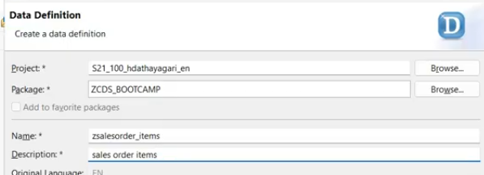
select the define view entity from template
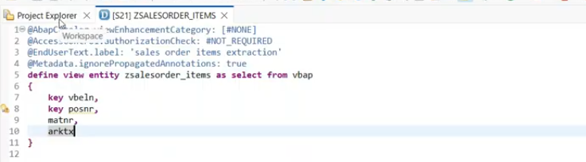

sales order header data:( data define entity)
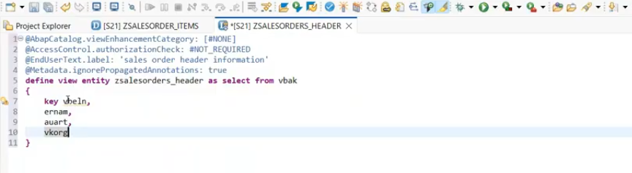

Associations:
Header and item entities are created, Now apply the associations and cardinality.
Key is mandatory, when you defining the entities.
default cardinality is [1..1]- if not written.
[1..1]
[1..*]
[0..*]
[0]
[1]
$projection- refers to the current entity fields.
Association- _<alias name>
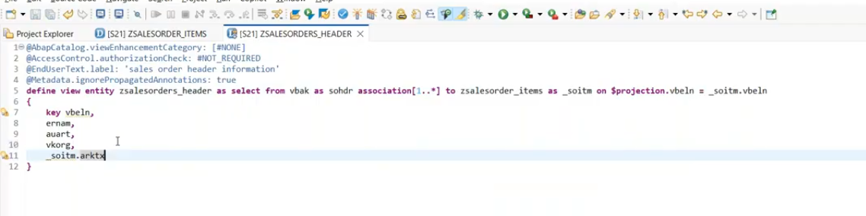
Output:
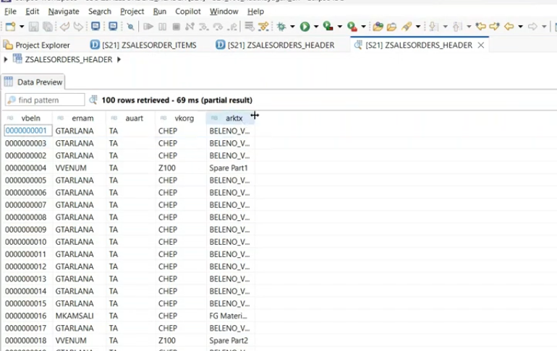
Suppose i am not fetching any association fields.. what happened here?
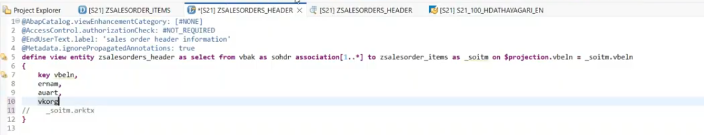
Output:
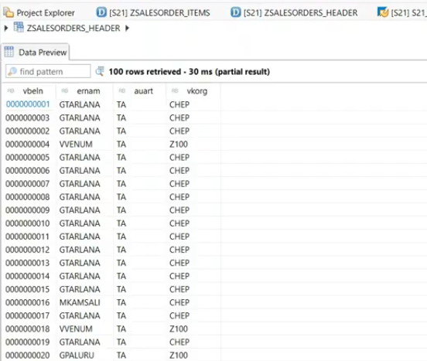
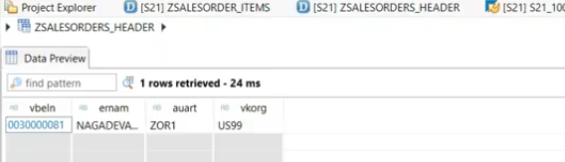
If you are not exposed any fields from the association set, associations data will not come and associations not mapped.- no associations defined.
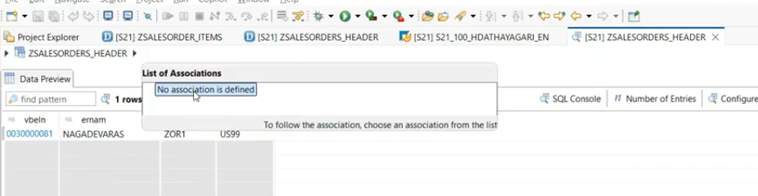

or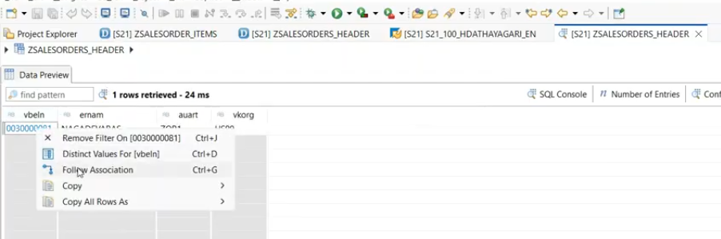
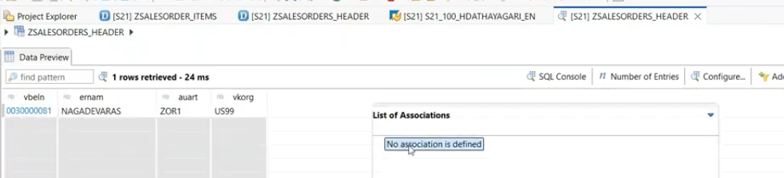
Here not exposed the entire association or association fields in output list.- means no association defined.. here if you use the association in select query also- it is not reflected.
Association data is visible when you expose the association in selection list.
No association defined means- Association not exposed inside selection list but association defined.

Exposing the Associations name in selection list:
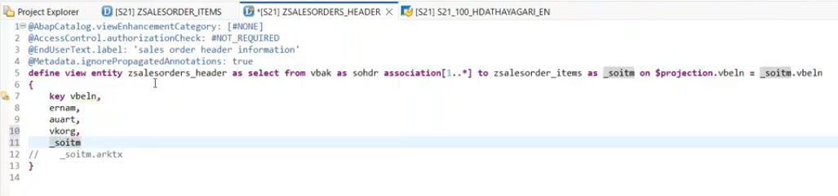
in joining we have to expose the fields in the selection list, but in association if we expose the line item alias name then entire cds entity as the association( all fields available in selection list)
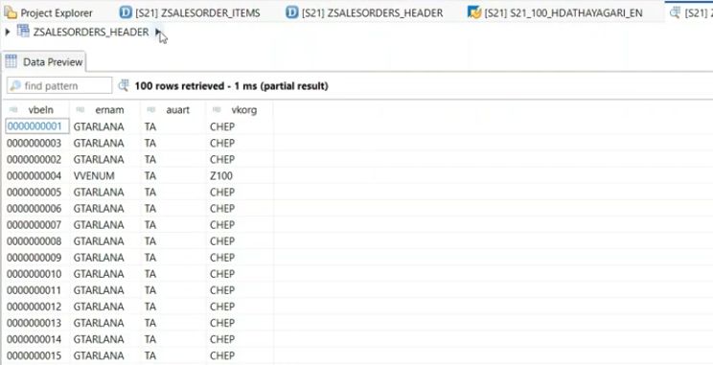
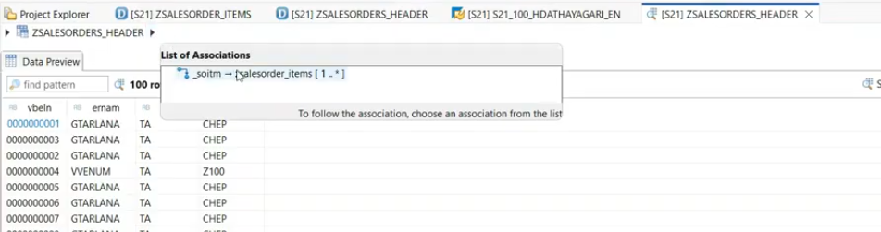
Now you can able to see the item associations.
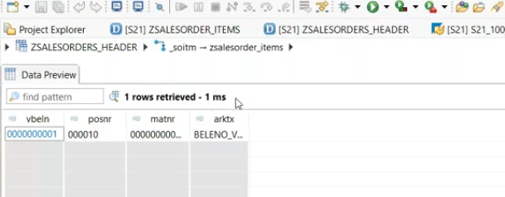
Now associations data exposed.
OR
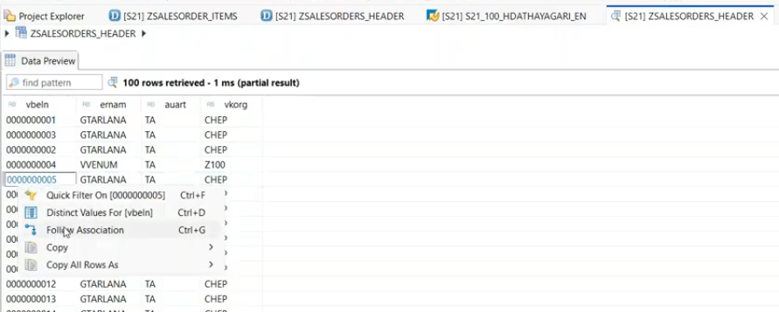
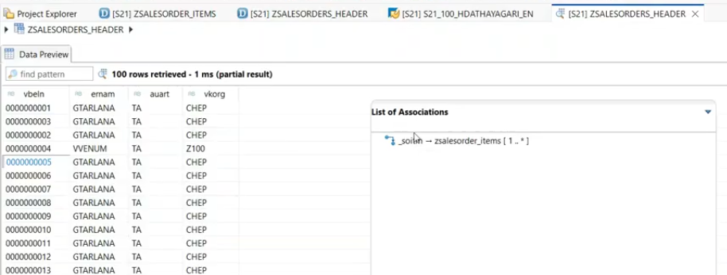
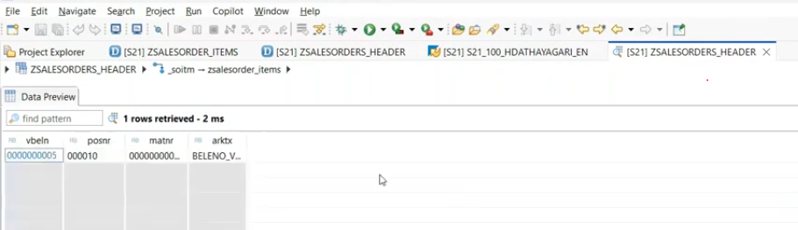
Uses: when you defining/exposing the odata services, association and navigation( the relation ship between the entities) will defined automatically because of associations.

Expose the odata service for sales header:
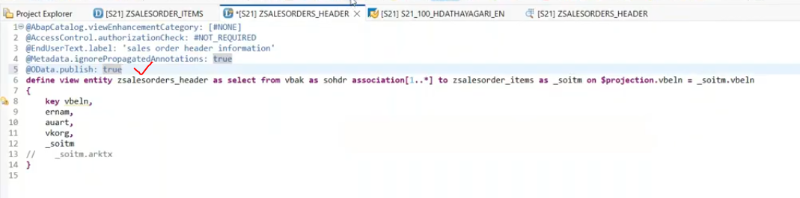
once activate the view.--> get the service name.
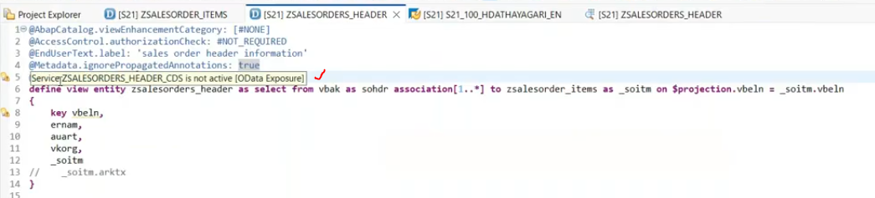
Copy the service name: ZSALESORDER_HEADER_CDS
register the service :/iwfnd/maint_service
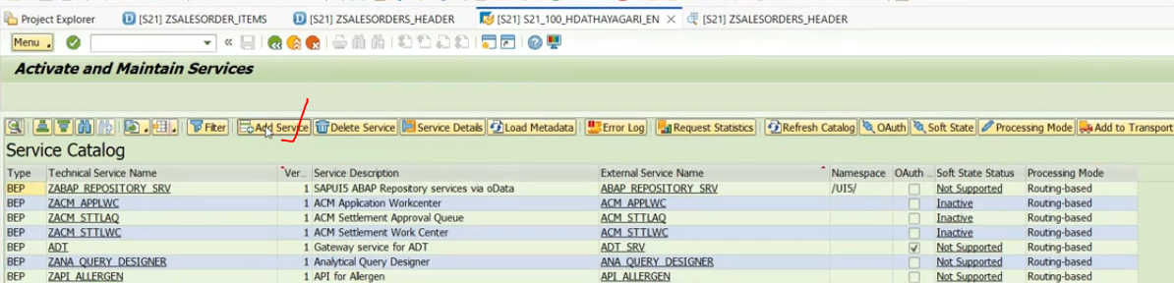
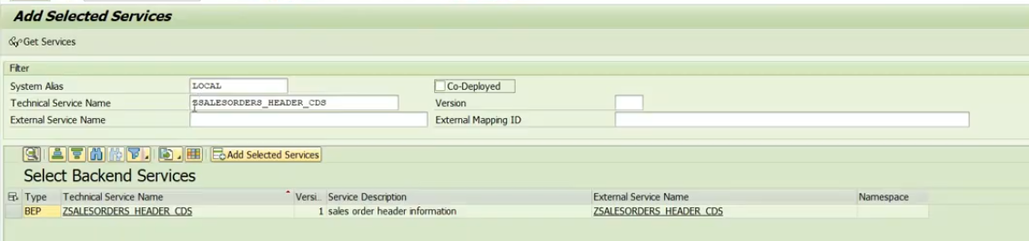
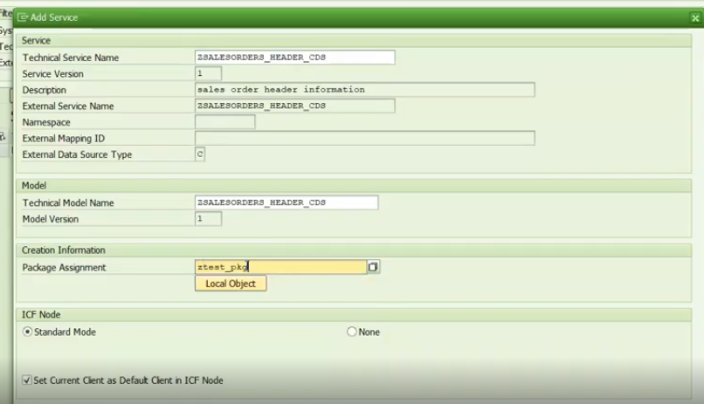
Once registered- search the service in same tcode.
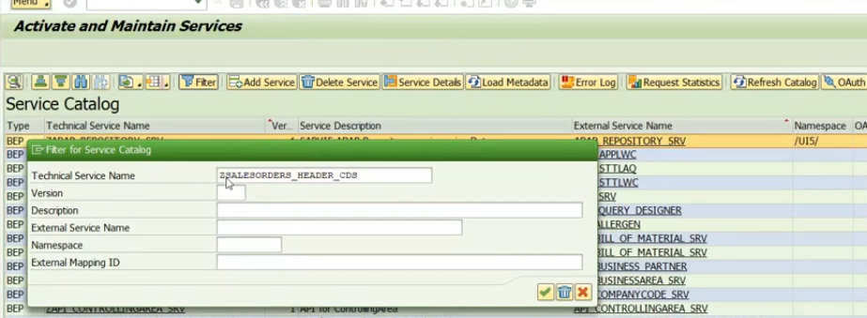
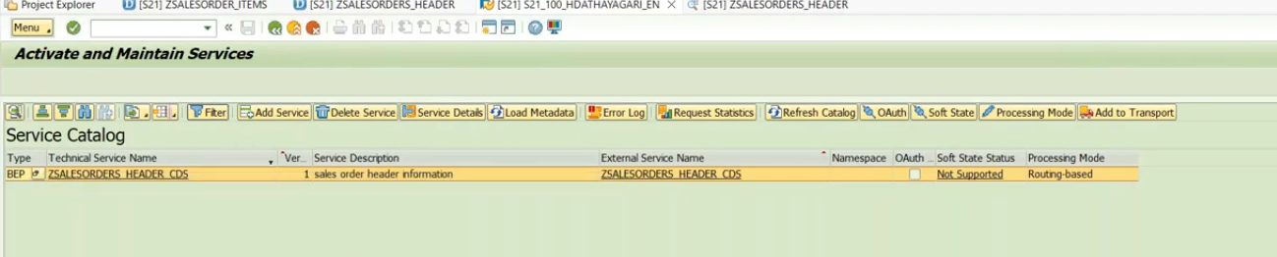
Navigation property available in metadata is "to<aasociation name>"
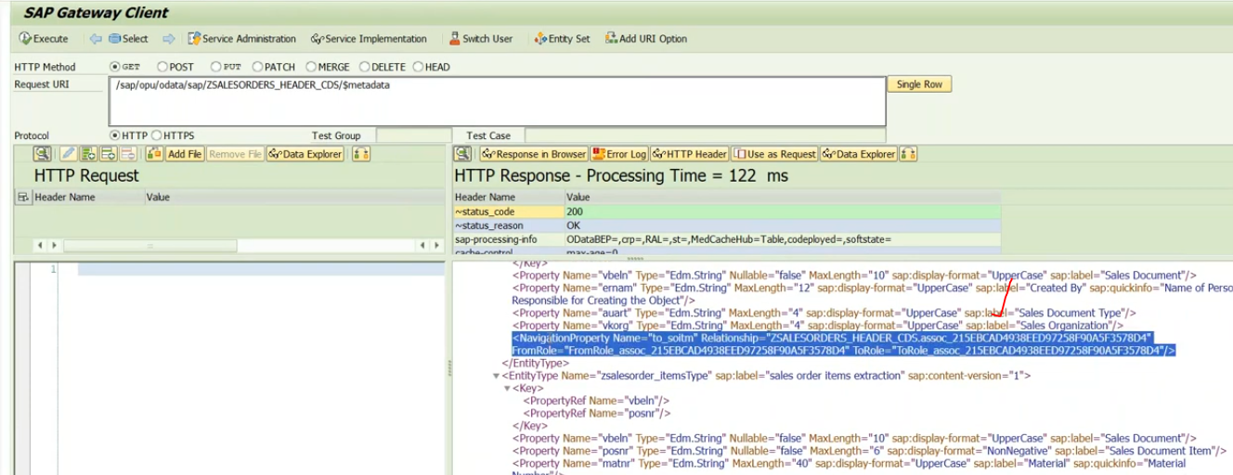
At ui5 , while defining the master and details page- master age we will map the header information and for detail we will map the navigation property needs to map.
29:32

AMDP: ABAP Managed Database Procedures
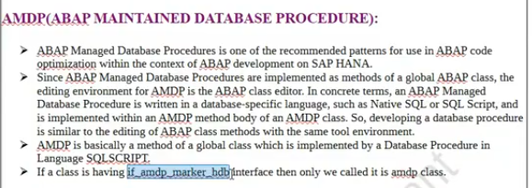
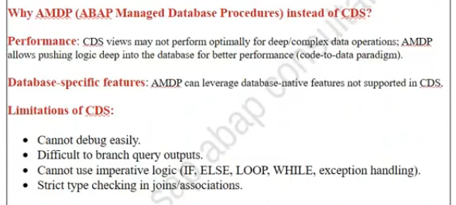
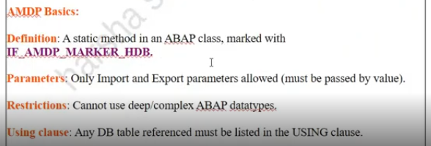
AMDPs are two types
1. Database Procedures
2. Database Functions
Database Procedures:
- We can't perform the DB operations.
Database Functions:
- We can perform DB operations.
AMDP can implement in OOPs code only, if class is having the interface- IF_AMDP_MARKER_HDB, then it is called as AMDP implemented class.
In AMDP, we can write the code in SQL script language.
Why AMDP?- CDS View can't handle the complex operations.
Ex: find days between the dates.- in ABAP we have the separate functions are available, but cds we don't have that functions. to perform this calculation we have to go with the AMDP. DB features not supported in the cds views.
so created on 2023 and till today how many days happend so created?
34:00
You can't debug the cds view
Native SQL not support in the CDS view
AMDP is basically global class.
in AMDP, we can use the SQL script.
For DB features- we can use the AMDP.
In cds view- while debugging we can't split the output.
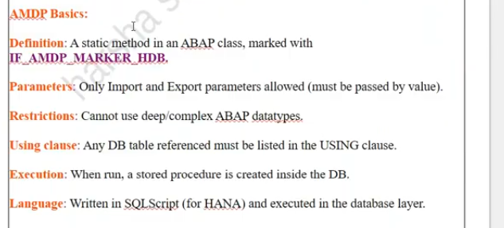
Create AMDP
-Class: ZCL_AMDP_TEST(Global)
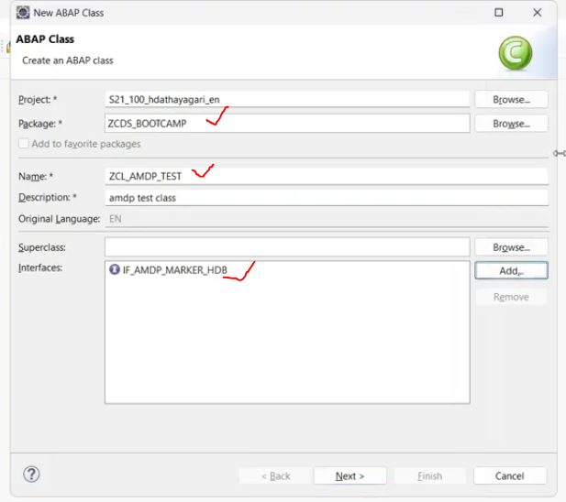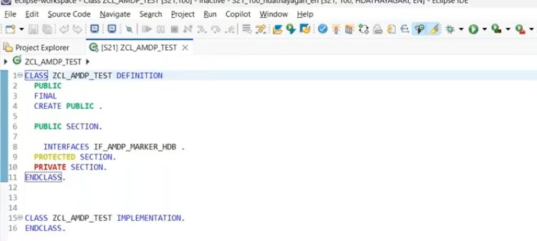
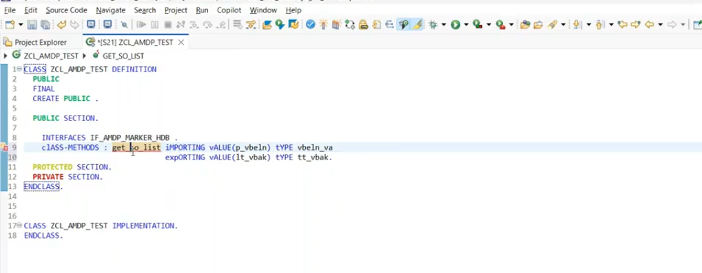
Select the method - press ctrl + 1 in the keyboard.. to create the method.
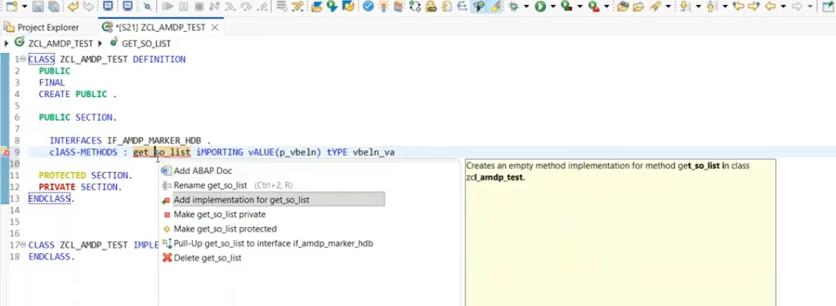
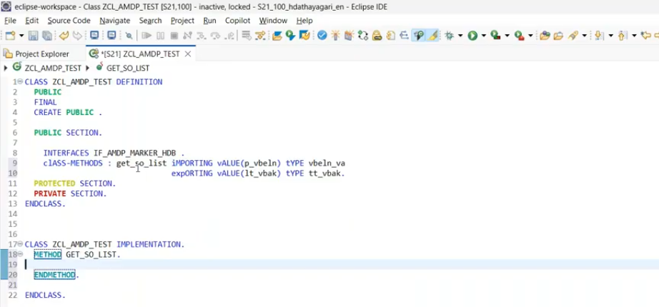
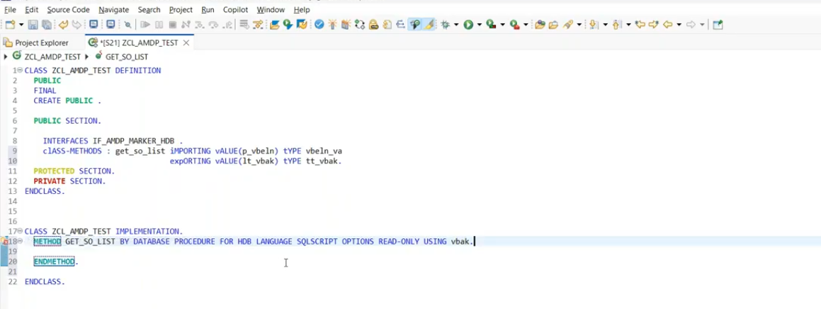
body of the AMDP can't be empty.
Whatever defined the using tabled in AMDP method implementation those tables should be consumed in the method implementation- otherwise through the error, if you are not using delete those.
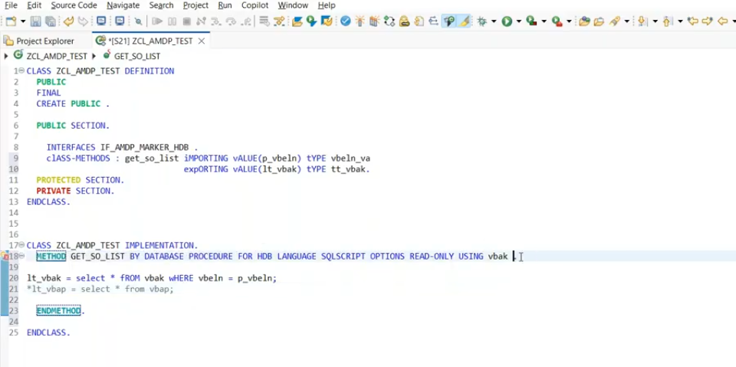
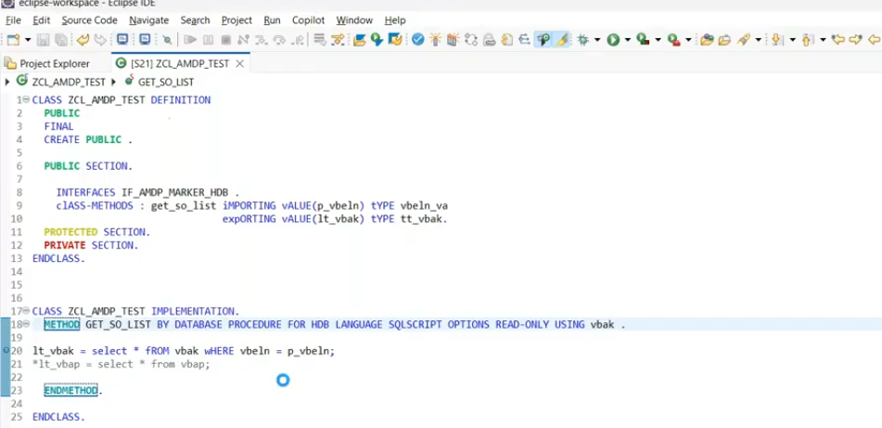
save and activate
Test
Open class
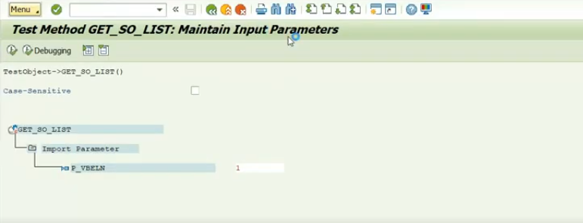
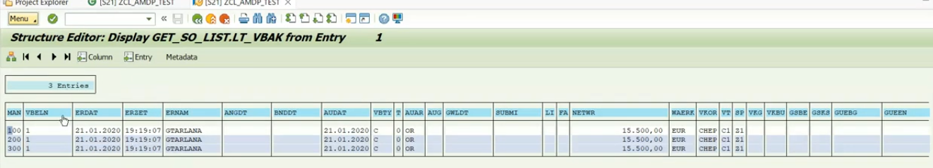
When you define AMDP with read only- can't perform update operations.
Send error-message record found from vbak table.
